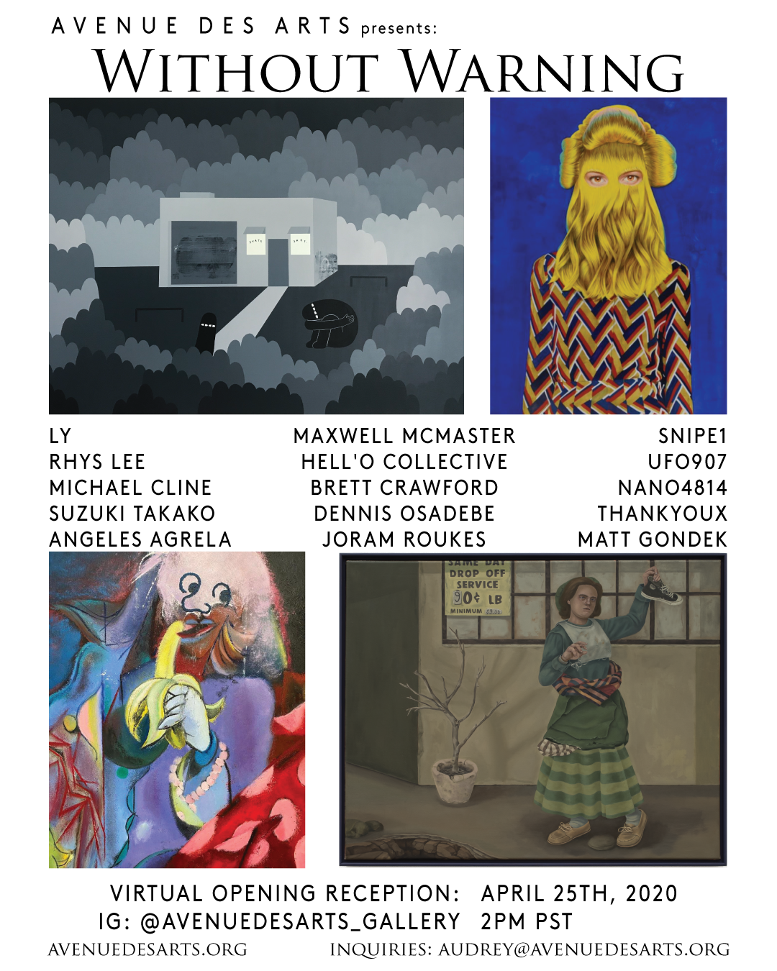

Avenue des Arts presents:

“Without Warning”

A Group Exhibition by

Hell’O Collective & Nano4814

LOS ANGELES

Opening Reception

April 25th, 2020 2PM PST

Instagram Live: @avenuedesarts_gallery

Virtual Tour: to be posted April 26th on our website

April 25th – May 30th

Avenue des Arts

807 S. Los Angeles Street

Los Angeles, CA 90014
For press and inquiries please contact Avenue des Arts at contact@avenuedesarts.org

Gallery- @avenuedesarts_gallery
Featured Artists  (click for Artist Statement) | ⁠Instagram
LY | @ly_painter⁠
Michael Cline | @michaelllcline⁠
Rhys Lee | @rhyslee_⁠
Joram Roukes | @joramroukes⁠
Suzuki Takako | @suzuki.__.takako⁠
Dennis Osadebe | @dennisosadebe⁠
ThankYouX | @thankyoux⁠
Matt Gondek | @gondekdraws⁠
Brett Crawford | @brettcrawfordart⁠
UFO907 | @ufo907⁠
Hell’O Collective | @jer_hellocollective⁠ & @antoinehellocollective⁠
Nano4814 | @nano4814⁠
snipe1 | @fukitalltokyo⁠
Maxwell McMaster | @maxwellmcmaster⁠
Angeles Agrela | @angelesagrela

IG Live Schedule:

2:00 - introduction

2:15 – Matt Gondek

2:30 – Michael Cline

2:45 – Maxwell McMaster

3:00 – ThankYouX

3:15 – Brett Crawfrord

3:30 – Rhys Lee

3:45 - Suzuki

Without Warning

Although, the Urban Art Fair Paris has been postponed due to the current global circumstances, we have decided to curate an exhibition with the pieces that would have been shown at our art fair booth. Avenue des Arts is proud to introduce "Without Warning", a virtual group exhibition featuring 15 amazing artists. These incredible paintings by Dennis Osadebe, Joram Roukes, Angeles Agrela, LY, ThankYouX, Matt Gondek, Michael Cline, Rhys Lee, Suzuki Takako, snipe1, UFO907, Hell’O Collective, Nano4814, Brett Crawford, and Maxwell McMaster, depict different aspects of our lives that relate to the current pandemic and the unfamiliar requirement to social distance. This will also be Suzuki Takako’s career debut into the art world.

The virtual Opening Reception will be on our Instagram Live, on April 25th, 2020 at 2 PM PST. One by one, the artist all over the world will join the IG Live in order to speak about how COVID-19 has affected their lives and discuss their pieces.

